**Proposal on**

**Feedback Management System**



**Submitted by Submitted to**

**Name: Utkrishta Bhattarai Module Leader: Sudeep Bajimaya**

**Class: 22’A’**

**Module: CP**

Contents

**Chapter 1 - Introduction** 3

**1.1.** **Project Introduction** 3

**1.2.** **Justification for the project** 3

**1.2.1.** **System Background** 3

**1.2.2.** **Problem Statement** 4

**1.3.** **Description of the project** 5

**1.3.1.** **Features** 5

**1.4.** **Overview of the system** 6

**Chapter 2: Scope of the project** 7

**2.1. Scope of the project** 7

**2.2. Limitations** 7

**2.3. Aims** 7

**2.4. Objectives** 8

**2.5. Overview of the scope** 8

**Chapter 3: Development Methodology** 9

**3.1. Description of the methodology** 9

**3.2. Design Pattern** 9

**3.3 Architecture** 10

**Chapter 4: Project Planning** 11

**4.1 Introduction of WBS** 11

**4.2. Milestone** 12

**4.3. Gantt Chart** 14

**Chapter 5: Risk management** 16

**Chapter 6: Configuration management** 19

**Chapter 7: Conclusion** 20

**Chapter 8: References and Bibliography** 21

Table 1:Milestone 14

Table 2: Likelihood Table 17

Table 3: Consequences Table 17

Table 4: Risk Management Table 19

Table 5: File Hierarchy 20

Figure 1 MVC Pattern 11

Figure 2:WBS Of the project 12

Figure 3: Gantt Chart 15

Figure 4:Gantt Chart 16

Key Words

Dissatisfaction, chunk, queries, authority, methodologies, deployment, framework, estimation, demonstrate, criticism, feasibility, calamities, milestone, visualisation, consequences.

# **Chapter 1 - Introduction**

## **Project Introduction**

This is a proposal for Feedback management system used to collect response/criticism from different members of an organisation. It is designed in order to collect review/criticism in an automated and systematic way so that Admin/Controller can view those review and take action on it.

## **Justification for the project**

In my view this project will help to uplift the business condition and will help to collect feedback easily and in efficient way. I have done feasibility study and found that this process will be feasible to develop. This project will give good return on investment and will help organisation in many ways.

### **System Background**

Feedback management system is a tool that can be used in an organisation. It is an effective tool for both small scale and large scale organisation. At present, in order to provide feedback or complain the higher authority is done by writing it in paper and then putting it into the suggestion box but after the implementation of Online Feedback management system paper work would be reduced and the review process would be much easier.

Process in which the effect or output of an action is returned to modify he next action. Feedback is essential to the working and survival of all the regulatory mechanisms found throughout living and non-living nature, and in man-made systems such as education system and economy **(Business Dictionary,2019)**. Any organisation wants its work to be done in an efficient way, for any organisation to grow more it needs feedback from its staffs and customers, also to know about the behavior of staffs collecting the feedback from different people is necessary. For e.g. in any college there are various staffs, teachers and students. A student can give feedback to any staffs and teachers that might be good or bad. Those feedback helps a lot to grow character of an individual and also know satisfaction and dis-satisfaction of students and parents. The feedback from customers are essential for any organisation as organisation is built from its customer in case of college students have high power so their feedbacks should be taken and they should be reviewed thoroughly. This will be very beneficial as it will reduce paper work and make the process efficient and also the Admin/Controller can view the Feedback according to various category. These feedbacks can help a lot to analyse staff’s behavior and monitor them if necessary.   
 However, the feedback is being processed in paper-based method which can cause dissatisfaction, problems and difficulties. Some of the problem statements are listed below.

### **Problem Statement**

Paper work can be cause data redundancy and they are difficult to maintain and document. The problems that any organisation may/can face with manual feedback system are described as below

* Data is not being used properly as it can be use

The feedbacks are stored in a separate chunk of paper manually and the data is not being recorded into database. If the amount of paper is full, they are scattered here and there so there is a great chance of the data being lost. The feedbacks are capable of doing a lot of improvements for any business organisation and also the data can be mined to discover various information.

* No online Feedbacks up-to now

We are in very high-tech world so people want everything to be delivered and accessed online. No one wants the process to be tough and boring. If anything can be accessed online people will find it easier and efficient. So, the feedback is being collected in a paper-based system which can cause difficulty to people. So, if the feedback collection is made online it will be a plus point for an organisation.

* Fraud

Not every people in this world is good. Bad people with bad intention can give false feedback (write unethical things). Since no credential are to be provided in paper-based system it might be difficult to track the people.

* Loss of Feedbacks/Data

The data can be lost. Since the data are to be stored in a wooden box in paper-based system there is greater chance of the paper getting destroyed. Even the suggestion box containing feedback can be destroyed in case of any calamities.

All of the problems mentioned can be solved in an easier way through the use of proposed feedback management system. Feedback/Data will be properly stored, utilized, analysed and maintained.

## **Description of the project**

This project will be developed in given time boundary. And after completion of this project the website will be tested in real environment and then only deployed in other system.

### **Features**

The proposed system/Website is capable of doing things listed below

* Displaying list of all staffs working in an organisation according to their department/category.
* Separate profile of each staffs and brief introduction about them.
* Allow the users to rate on any staff's/people profile.
* Provide separate feedback for any staffs/people registered into the system.
* Allow users to register into the system and login into the system using the credentials.
* Allowing users to chat with other users in a community forum.
* Allowing users to update delete their account if necessary.
* Allowing the system admin/Controller to register any staffs in the system.
* Allowing Admin to view feedbacks received and reviewing them.

## **Overview of the system**

Basically, the whole concept of the system is to build an online feedback management system in which user can post their feedbacks, queries and admin can view it and review them.

# **Chapter 2: Scope of the project**

## **2.1. Scope of the project**

An IT technology helps to promote a business. It helps a business towards sustainable development. The proposed website will create a better vision for the fusion. Users will provide feedback in the website for the people they want, this will save the time and make the higher authority easy to view and document them properly.

In order to build this system, I have made uses of following programming languages and resources.

* Presentation layer: HTML, CSS, JavaScript, jQuery
* Framework: Laravel
* Design Pattern: MVC
* Database Server: MySQL
* IDE: Php Storm

## **2.2. Limitations**

This program won’t be able to provide following functionality

* It won’t provide a list of most liked and disliked staffs in an organisation.
* It won’t have functionality of direct messages between staffs and user.

## **2.3. Aims**

The major aims of the project are as listed below

* To build a dynamic website for storing, managing, analysing and filtering the feedbacks of any organisation.
* To build a user-friendly website for motivating users to provide more and more feedbacks which will help in uplifting the business.

## **2.4. Objectives**

Main objectives of the project are listed below.

**Project Objectives**

* To build the website being within the budget and under given time boundary.
* To build an accessible, user-friendly and reliable website.
* To get rid of loss of feedbacks.
* To ensure security of users using the website.
* To strengthen the relationship between various staffs of an organisation.
* To get rid of old paper-based feedback process and implement online system for collecting feedbacks.
* Making admin/controller to easily view feedback and review them accordingly.
* To ensure user satisfaction and make the feedback process efficient.

**Personal Objectives**

* To acquire knowledge on various programming language.
* To get knowledge about Software development methodologies and ways to implement them.
* To know how a complete website is designed and executed.
* To develop skills and problem-solving strength.

## **2.5. Overview of the scope**

So, a complete website is to be made with the help of required resources which will have minimum amount of limitation and the main aim of building the system is to make feedback system efficient.

# **Chapter 3: Development Methodology**

## **3.1. Description of the methodology**

A software development methodology refers to the framework that is used to structure, plan and control the process of developing an information system. (CMS,2019). Any development methodologies help to grow a project in efficient and manageable way. For completing this project, I have decided to use Waterfall Methodology. Waterfall methodology is easy to use and understand as it ensures that each phase should be completed before entering in next phase. In this methodology phases do not overlap. I have used Waterfall method because the project is to be completed in time. Also, the requirements are gathered correctly so that there is no need of rolling back to the previous phase. To complete my project in time and show the progression level of how the project is being developed, I have made use of waterfall methodology. The phases in Waterfall methods are

* Requirement Gathering
* Analysis
* Design
* Implementation
* Testing
* Deployment
* Maintenance

## **3.2. Design Pattern**

In order to build this project, I have made use of MVC design pattern. M, V, C in MVC represents Model, View, Controller respectively.

**Model**

It stores raw data and it outlines essential mechanisms of application. It can have a logic to update controller code if data is changed.

**View**

It demonstrates the visualization of data that is used by model.

**Controller**

It performs on model and view both. It also regulates the data flow into model object and updates view when data varies. It supports to keep both model and view separate.

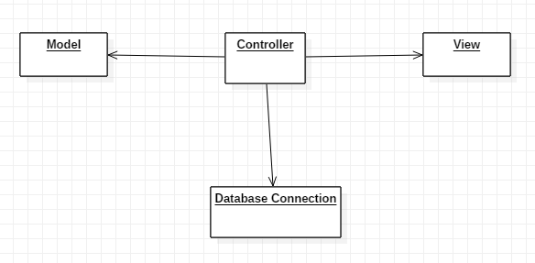

Figure 1 MVC Pattern

## **3.3 Architecture**

For developing this project, I have made use of 3 tier architecture along with Laravel framework (Stackoverflow,2019). In this type of architecture there are three tier they are

* Presentation tier: This consist of Views and controllers from the MVC pattern.
* Business tier: It consist of Model (Data) from MVC pattern.
* Data Access tier: Data is accessed by application layer with the help of API call.

# **Chapter 4: Project Planning**

In order to complete the whole project, the required estimated time is 108 days. Different tools and application are used in order to build the system such as Project libre, Star UML and many more. I have designed a schedule for task to be done according to the sequential order and prioritizing each phase.

## **4.1 Introduction of WBS**

In order to complete a project in efficient manner and being within given time constraint the works should be divided accordingly and they should be prioritized. Work Breakdown structure (WBS) is used in our project to ensure that the project will be completed in time and in a hassle less way. WBS structure is used as it helps for correct estimation of cost, risk and time.

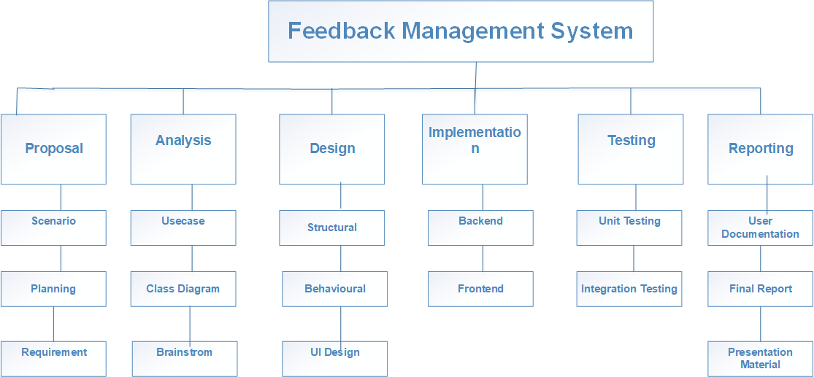

Figure 2:WBS Of the project

## **4.2. Milestone**

In order to check the progress level of the project and ensure that the project will be delivered in time, we take help of milestones. It is a process to observe, monitor and measure the performance of the project. It acts as a proof in future for reporting and explaining the status of the project.

Milestone is used in order to

1. To spot the start of important phases of work.
2. To mark the deadlines for different phases.
3. To demonstrate at what time some important project is being done.

The produced milestone for my project is given below

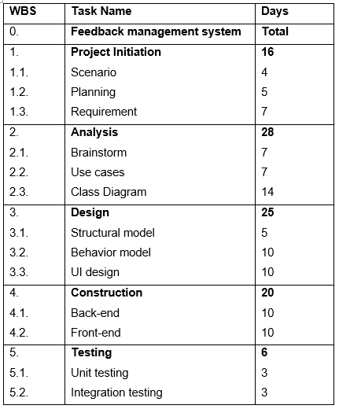

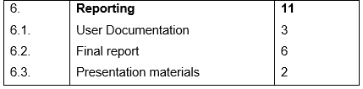

Table 1:Milestone

**Project Initiation**

This phase requires 14 days. In this phase feasibility study is done, requirement is captured and a document is written. The document consists the project introduction, scope of the project and other various things.

**Analysis**

This phase will take estimated time of 28 days. In this phase various diagram are prepared. Static and dynamic diagram are designed in this phase. Class diagram, sequence diagram, Activity diagram etc. are prepared in this phase. Brainstorm, use-case diagram is also designed in this phase.

**Design**

This phase will take an estimated time of 25 days. In this phase behavioral diagram as well as structural design is done. Database, programming language to be used is also selected in this phase. UI is also designed in this phase so 25 days is allocated for this phase.

**Construction/Implementation**

After all diagram are made and the resources required are decided, coding is done. In this phase back-end and front-end is developed. This phase will take estimated time of 20 days.

**Testing**

After the coding part is done, to check how the system is made, we take help of testing. Various testing like Blackbox Whitebox, integration testing is done in this phase to ensure that the website made is ready to use and is free from bugs. It will require 6-7 days.

**Reporting**

After the testing is done, the documentation is created. Each and every step required in the complete project is recorded in a document. Also, the presentation file is also made in this project. This phase requires estimated time of 11 days.

## **4.3. Gantt Chart**

A Gantt chart is a useful tool represented in graphical way which help to show task and activities performed against time (The Economic Times,2019). It is visual presentation in which activities are broken down and is shown in a chart which assists in understanding the system easily. Gantt chart is used for scheduling task purposes in any big or small project.

For our project I have made use of Project Libre for drawing Gantt chart. Gantt chart for my project is given below:

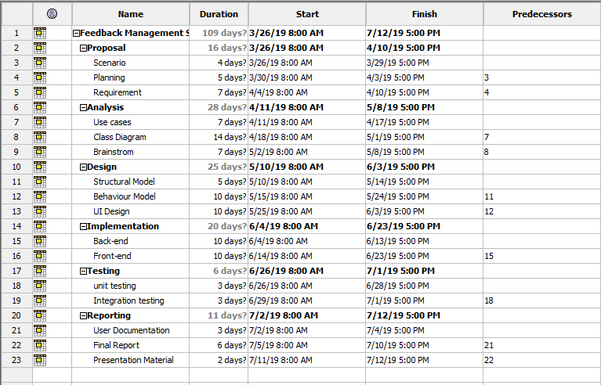Figure 3: Gantt Chart

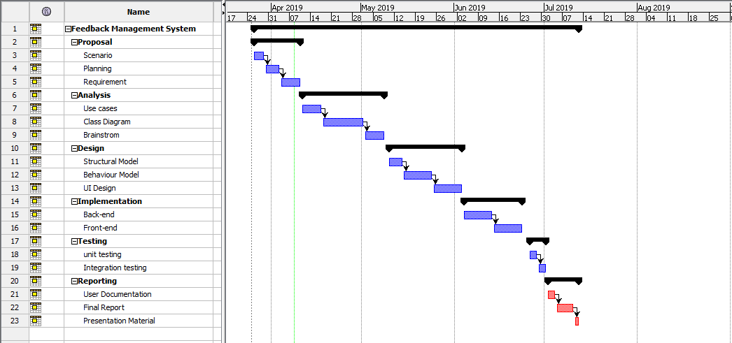

Figure 4:Gantt Chart

# **Chapter 5: Risk management**

It is the practice of classifying potential risk that in initial phase by analysing them and using precautionary steps to minimize the risk. This is known as risk management. For any business activity the result is uncertain, they are prone to various risk. Risk in a project can even cause a project to be shut. So, risk management assists to produce a defensive way to minimize the risk that could arise in the development of project. It also helps to estimate the impacts of various risks that could arise on future. It is able to understand and tackle the risks.

Risk management helps in finding the impacts of each provided risk. There is a formula for calculating risk, it is given below

*Impact = Likelihood * Consequences*

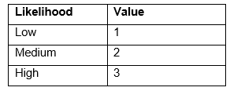

Table 2: Likelihood Table

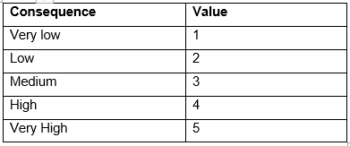

Table 3: Consequences Table

Some of the risk that could be faced and their impacts are given below:

1. Organisational risk – The organisation may decide to shut down the project or they may decide to hand over this project to other developer.
2. Usability risk – The end user as well as the admin might find difficulties in accessing the website.
3. Viability risk – There may be use of lot of resources, time and money.
4. Changing requirement – There is less possibility of change in requirement but also there might be change in requirements.
5. Unauthorized access – Website is very prone to unauthorized access/ hacking.
6. Server Crash – The server sometimes may get crashed so there might be availability issues.
7. Data theft – Data might be stolen as the feedback are important to any organisation.

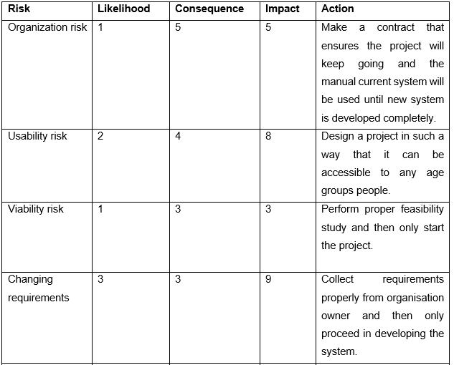

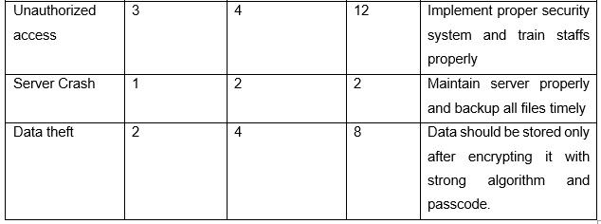

Table 4: Risk Management Table

# **Chapter 6: Configuration management**

Configuration management is the process of creating and continuing consistency of any products performance, physical attributes and functional attributes with the requirement, design and information throughout its existence. It comprises the source code, test code, software (third-party), data and also documentation files. These data are saved carefully and they are managed with great care throughout the project lifecycle. These files are safely back up in a separate folder and after every 10 days backup files are updated. Also, I have used version controller for GITHUB and also, I have uploaded the project files in Cloud storage (Dropbox) so that I can easily rollback to the previous steps. Also, if any files get corrupted, I can easily get the backup and then work on my project.

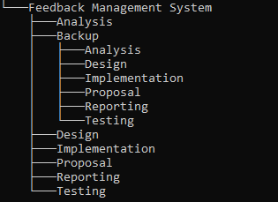

Table 5: File Hierarchy

# **Chapter 7: Conclusion**

Implementation of online system is the efficient and easy way to uplift the business. It is a bright opportunity for any organisation to implement online feedback system. Finally, full documentation on how current manual paper-based system is changed into online paper-less system is made.

# **Chapter 8: References and Bibliography**

1. Cms.gov. (2019). [online] Available at: https://www.cms.gov/research-statistics-data-and-systems/cms-information-technology/xlc/downloads/selectingdevelopmentapproach.pdf [Accessed 3 Apr. 2019].
2. The Economic Times. (2019). *Definition of Gantt Chart | What is Gantt Chart ? Gantt Chart Meaning - The Economic Times*. [online] Available at: https://economictimes.indiatimes.com/definition/gantt-chart [Accessed 2 Apr. 2019].
3. Gordon, A., 2014. *What is a Work Breakdown Structure?.* [Online]   
   Available at: http://www.brighthubpm.com/templates-forms/2645-what-is-a-work-breakdown-structure/#imgn_1  
   [Accessed 2 Apr. 2019].
4. Ravihansa, D., 2015. *System Development Methodologies.* [Online]   
   Available at: https://www.slideshare.net/devonravihansa18/system-development-methodologies-45452837  
   [Accessed 4 Apr. 2019].
5. Sharma, L., 2017. *Configuration Management.* [Online]   
   Available at: http://toolsqa.com/software-testing/configuration-management/  
   [Accessed 5 Apr. 2019].
6. sheffield.ac.uk, 2012. *How to: Write a Problem Statement.* [Online]   
   Available at: https://www.sheffield.ac.uk/polopoly_fs/1.440722!/file/HowtoWriteaProblemStatement.pdf  
   [Accessed 8 Apr. 2019].
7. smartsheet, 2016. *How to Write a S.M.A.R.T. Project Objective.* [Online]   
   Available at: https://www.smartsheet.com/how-write-smart-project-objective  
   [Accessed 29 March. 2019].